**[](http://waado.org/Contents.html)**

***Headquarters:***

**No. 3 Ekeh Street (Opposite Catholic Church)**

**Okpara Inland, Ethiope East LGA, Delta State, Nigeria**

**P. O. Box 652 Effurun, Delta State, Nigeria**

**Telephone Enquiries: 07060647530, 07037982410**

**Websites:** [**www.waado.org**](http://www.waado.org)**; urhobodigitallibrarymuseum.com**

May 12, 2022

**THE URHOBO PEOPLE, THE URHOBO PROGRESS UNION**

**AND THE 2023 ELECTION OF THE GOVERNOR OF DELTA STATE**

The Urhobo Historical Society (UHS) has watched, with some degree of concern, the rather fractious debate which has ensued in the wake of the endorsement, by the Urhobo Progress Union (UPU), of a gubernatorial candidate in the pending primary election of the People’s Democratic Party in Delta State. In the several weeks since the UPU announced that endorsement, across many platforms, sons and daughters of Urhoboland, patriots one and all, have been engaged in a contentious debate on this action of the UPU.

As the debate raged, seemingly complete with rebuttals and surrebuttals, there were calls for UHS to offer its views on the matter. But UHS chose not to do so; it chose instead to remain silent, until now, the better to allow passions to subside, in the hope that in time, invective will yield to reasoned arguments and considered judgments. UHS applauds the demonstrated commitment to the interests and the welfare of the Urhobo people, on the part of all who have been parties to this debate, but, as it does so, it is compelled to decry the unfortunate and unacceptable recourse to vituperation, calumny and incivility which were so often on daily display. If we, the people of Urhoboland, are to win the day in the many battles that await us, a firm sense of unity and common purpose, anchored to an abiding belief in reason as the most potent of our weapons, must be our guiding star. It is against this background that UHS has considered the substance of the communique issued by the Executive Committee of the UPU, on April 17, 2022, on the 2022 primary election of the PDP for the office of Governor of Delta State.

It must be noted, in the first instance, that the Executive Committee **DID NOT** endorse a candidate for the Office of Governor of Delta State in that communique. Contrary to the claims in many of the public submissions on the matter, **the UPU Executive did two things, and only two** things in that communique. **First**, it announced its endorsement of a candidate in the **PDP primary election**for the office of Governor of Delta State, and **Second**, it announced its intention to repeat the exercise in the subsequent primaries of other political parties if the candidates who seek the nominations of those parties for the office of Governor of Delta State include sons or daughters of Urhoboland. Our expectation is that the Executive Committee will fully implement this plan by repeating this exercise in the pending primary elections of other political parties in which a son or daughter of Urhoboland is a candidate for the governorship of Delta State. These, we submit, were the central messages of that communique. As we read it, the animating reason which guided the Executive Committee in this action, was and remains the unyielding belief that the person elected to the Office of Governor of Delta State in 2023, **MUST** be a son or daughter of Urhoboland, combined with a defining commitment to ensuring the same. This singular goal of securing the election of an Urhobo son or daughter as the next governor of Delta State is fully shared by the Urhobo Historical Society.

Fault could well be found with the process which the UPU Executive employed in arriving at its decision to endorse one of the aspirants for the PDP nomination. Multiple avenues were available to it as it sought to endorse the Urhobo candidate who, in its judgment, could best fulfill the duties of the office. The choice of which of these avenues to take and the process to employ was the Executive Committee’s to make. While UHS or any other group might well have chosen a different avenue and/or a different process, that mere fact, standing alone, does not make the choice of the UPU Executive in this instance suspect or invalid. We must allow our leaders (working hard and selflessly on our behalf) some room to act on what they reasonably consider to be in our collective best interest. Even where we disagree with a decision or with the process which was used in arriving at that decision, we **must** **never** allow the ideal to be an enemy of the good. No individual or group is blessed with a monopoly of the truth. It behooves us, therefore, to apply modesty in the sweep of our pronouncements and in our conduct in the public square.

Those among our ancestors who had the ability to look straight and around the bend, saw the need for an organizing institution which could serve the collective interests of all Urhobos, and they worked hard to secure and advance those interests for themselves and for their progeny. Over ninety years ago, in a demonstration of prescience that time has revealed to be truly remarkable, they founded what is today the Urhobo Progress Union. Because, in the end, organizations are populated and administered by the persons who belong in them, the foibles of the humans who constitute the Urhobo Progress Union have made for some difficulties in our lives as Urhobos and in the stewardship of the UPU. But, fortunately, thanks to the fortitude of and the fierce commitment of many of our compatriots, the UPU has weathered many of the storms with which it has had to contend over these ninety years, and has, at every such turn, found a safe harbour. There will surely be many more trials in the years ahead, but if all of us, the daughters and sons of Urhoboland, commit ourselves to improving the UPU, saluting it when it is in the right, and offering constructive criticism, devoid of public rancor, when it errs or loses its way, the result is likely to be a better and stronger UPU, fully engaged in the service of the Urhobo people as it does battle for us in the offices and in the corridors of power in the extant rendition of the Republic of Nigeria. If, however, by our actions or through the agency of the written word we decapitate the UPU, we, Urhobos all, shall be the losers, because we would have rendered prostrate the most important Urhobo organization. There is a choice to be made, and we should take care to choose wisely and make the correct call.

This, too, is true in the immediate choice which we as a people must make on the pending matter of the next Governor of Delta State. The Urhobo Historical Society has no preferred candidate for the office. It insists only that all Urhobos must be careful and make certain that the man or woman who occupies that office at the conclusion of the electoral process is the Urhobo person best suited to faithfully discharge the duties of the office in genuine service of the citizens of the state. In our considered view, what remains now is for Urhobos, one and all, to come together, united in common purpose, and to act deliberately and with calculation to protect our interests. A state of affairs in which contending personalities remain unmindful of the political realities and the dangers that we face as a people in the brutal political space that is the Republic of Nigeria, and in which they see politics in Urhoboland as a war between and among enemies, will ill serve us. In the circumstances, it is our considered view that if we as a people are to be protected, made safe and our future secured, we urgently need irenic men and women across Urhoboland who, with peace secured at home, can lead us in our struggles in the larger society where the real battle must be joined.

It is, therefore, the fervent hope of the Urhobo Historical Society that as we contemplate these matters and choose a way forward, we will be guided by the seminal words of Chief Mukoro Mowoe who once so admonished his beloved Urhobo. ***My belief is that every being born into this world has a duty to perform for his people, either at the village, town or country …. Frankly speaking, any one of you (Urhobo people) who should fail to play his or her part for the uplift of our dear tribe, it would be better that she or he had not been born****.* If, as Urhobos, we adopt the words of the Chief as our North Star, we might just succeed against the travails we now face. At a minimum, we would have given our full measure, and that would be excellent. Anything less would be a grand betrayal of our ancestors and our progeny for which, we fear, they would never, ever forgive us, and justifiably so.

We thank you, one and all, and we wish you the very best as we work together for our common good.

All best wishes,

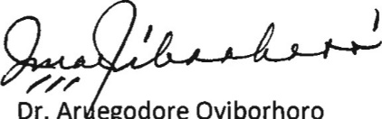

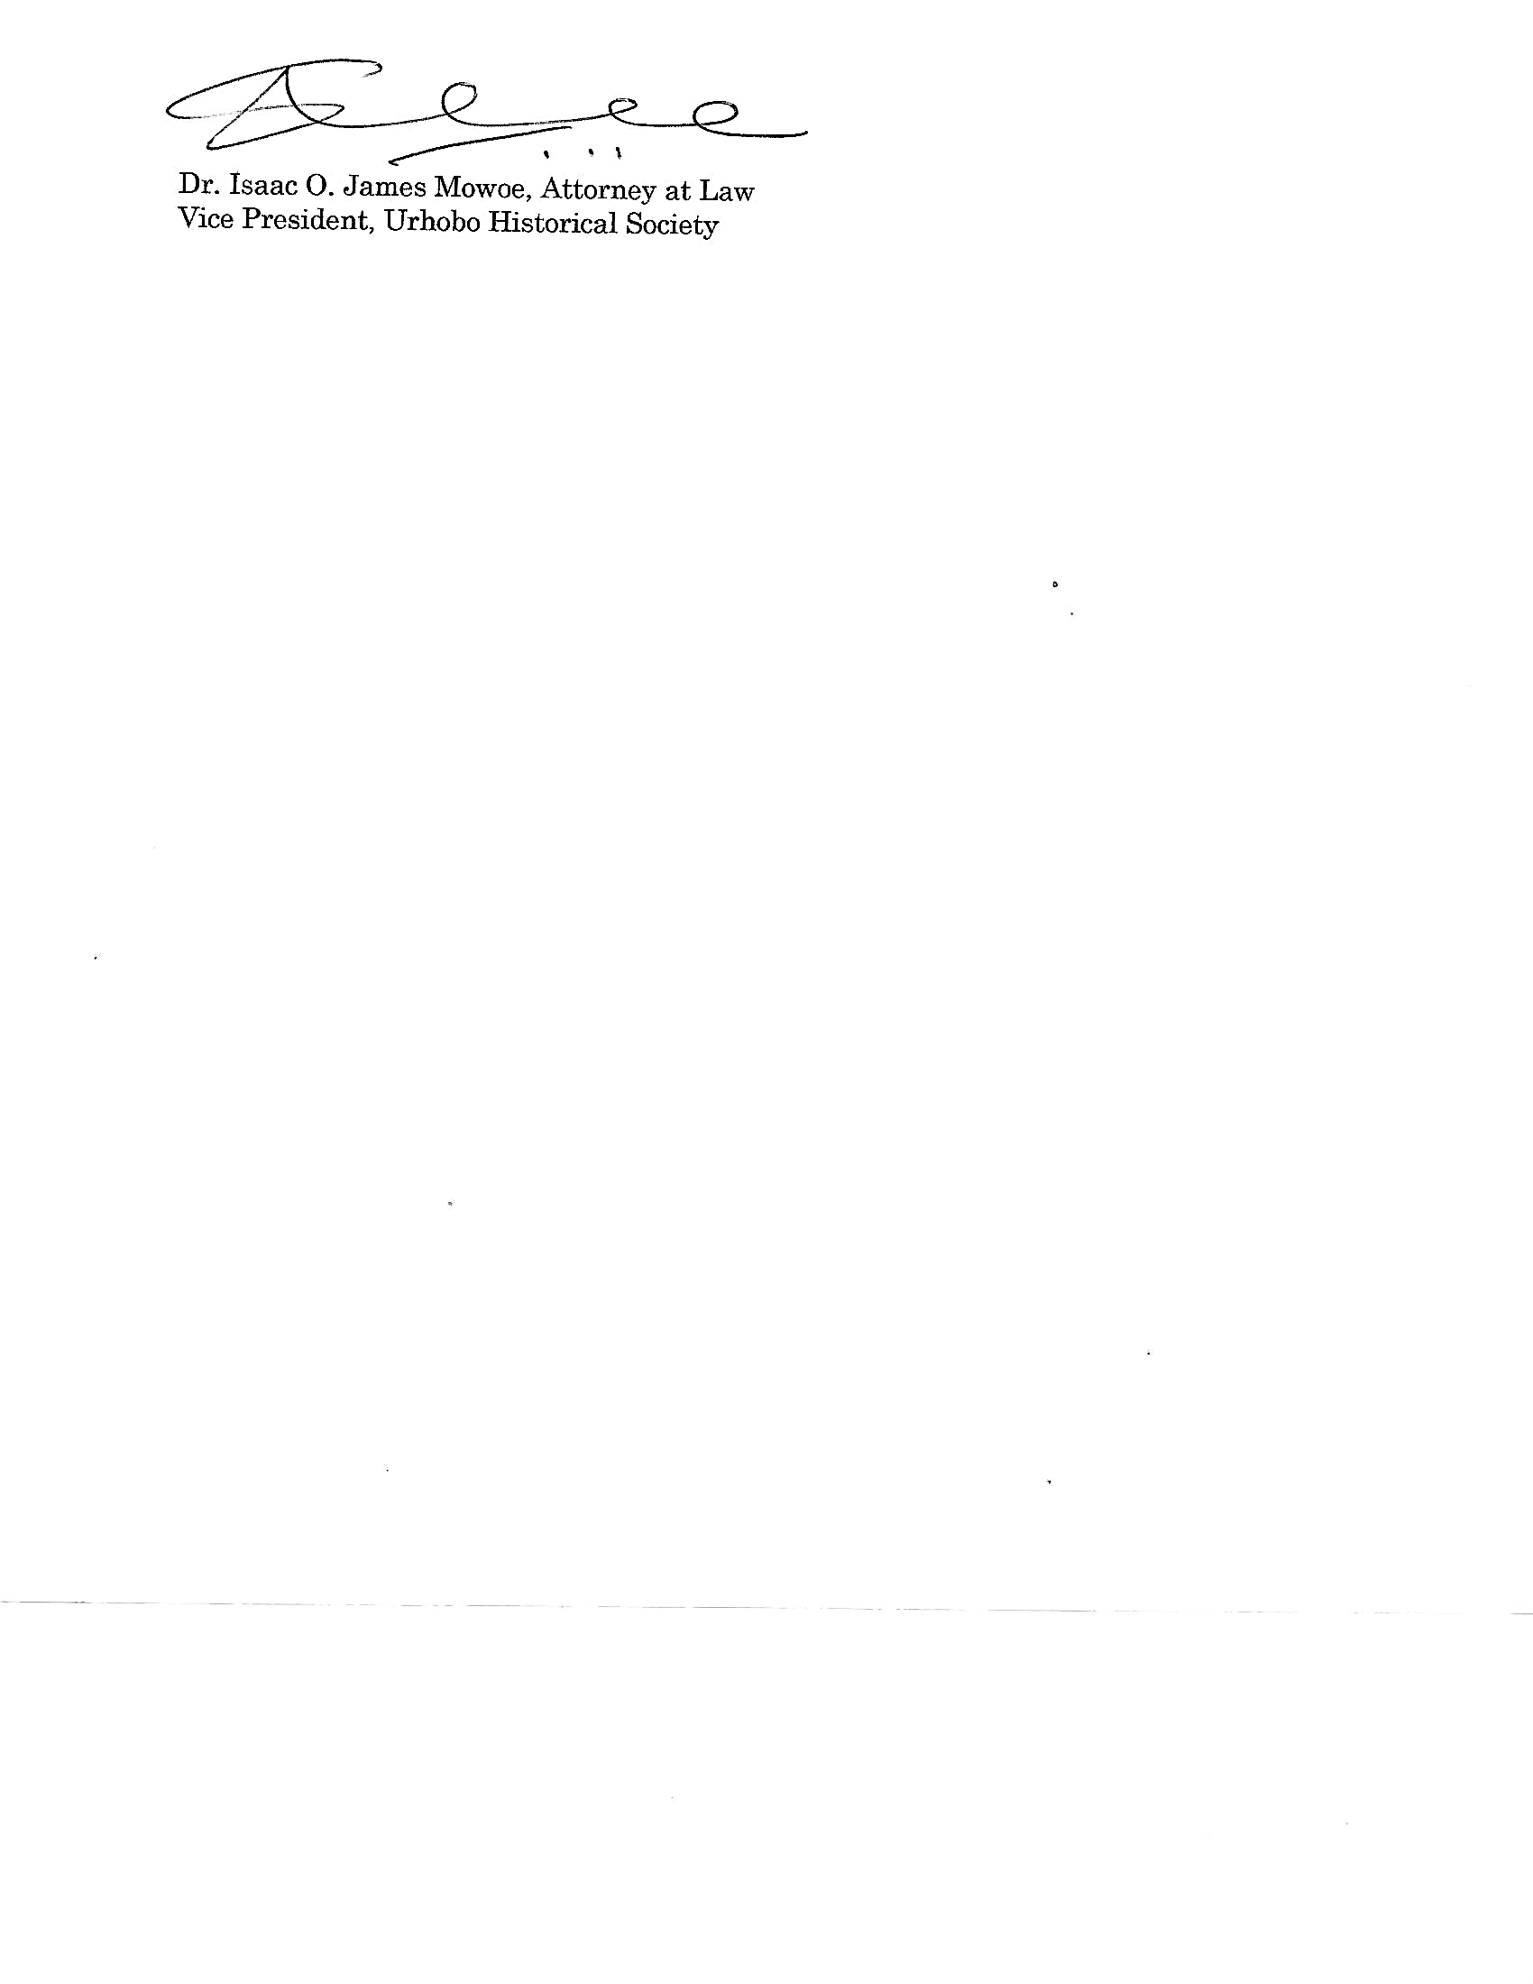

Dr. Aruegodore Oyiborhoro, Dr. Isaac O. James Mowoe

President Vice President

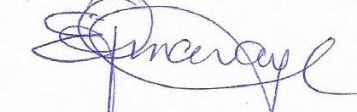

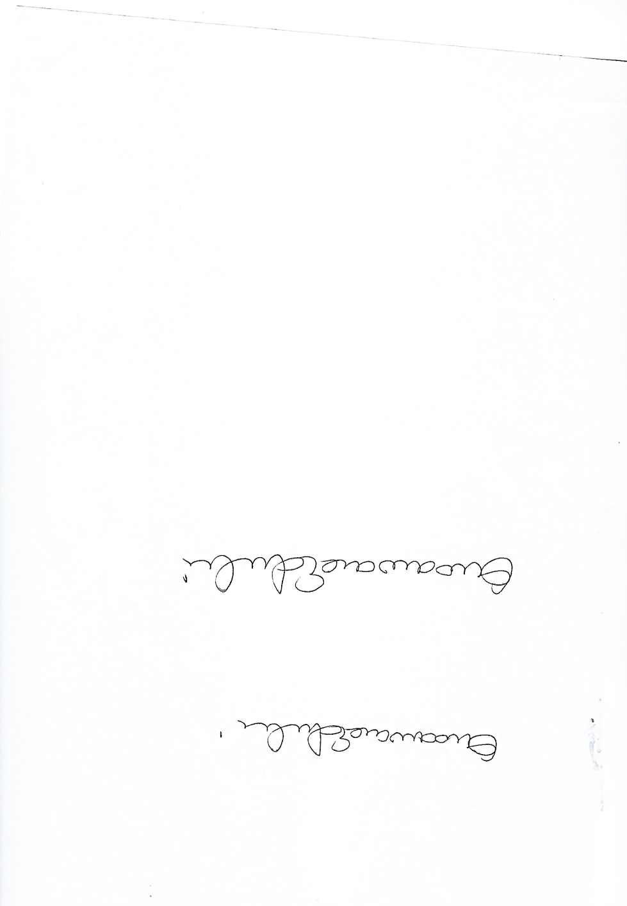

Engr. Andrew Edevbie Dr. Emmanuel Ojameruaye Secretary Treasurer